Ohio Department of Transportation

Ohio Contractors Association

Don Conaway Partnering Award

2023 Nomination

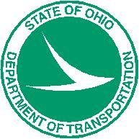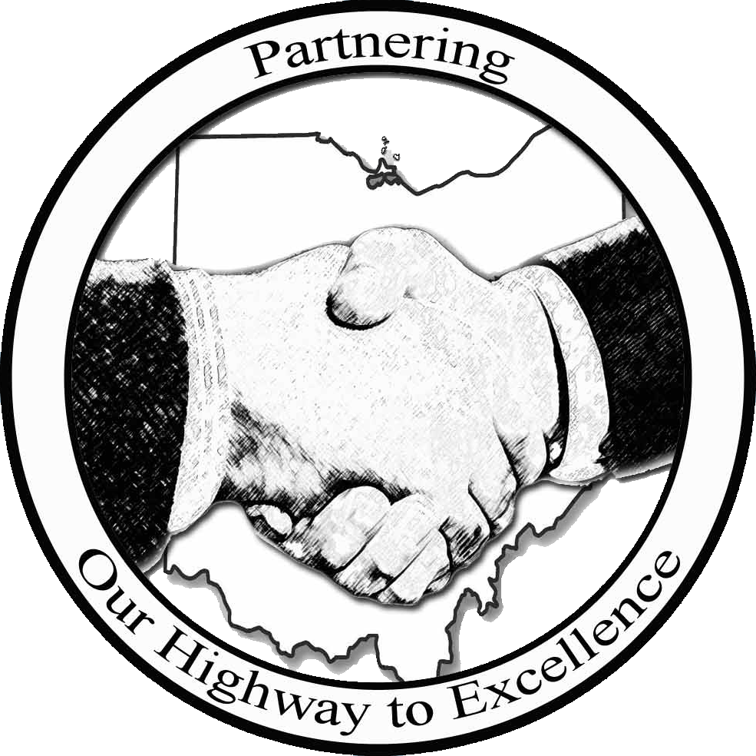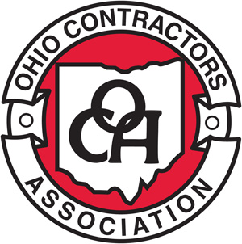

Nomination Deadline: Friday, January 6th, 2023

1980 West Broad Street
Columbus, Ohio 43223

www.dot.state.oh.us/pages/home.aspx

www.ohiocontractors.org/default.aspx

DON CONAWAY PARTNERING AWARD CATEGORIES

A project team, consisting of the Contractor and ODOT, will be recognized in each of the following project categories:
- Category 1 – (Under $5 Million)
- Category 2 – ($5 – $20 Million)
- Category 3 – ($20+ Million)

2023 ELIGIBILITY REQUIREMENTS

- Projects must be substantially complete by December 31, 2022.
- All ODOT let construction projects are eligible.
- A project can only be nominated once for consideration of this Award.
- Projects must be nominated jointly by both the Prime Contractor and respective ODOT District.

AWARD PROGRAM GUIDELINES

Nomination Deadlines and Submittal Information
Nominations to be sent/ emailed to:
Chase Wells, ODOT Partnering Coordinator – by Friday, January 6th, 2023
1980 West Broad Street
Columbus, Ohio 43223
Mailstop 4090

For questions contact:
Chase Wells, 614-466-4789, Chase.Wells@dot.ohio.gov

Selection Criteria (No particular order)

  - Establishment and achievement of goals.
  - Management of Key Stakeholder and Subcontractor relationships.
  - Challenges encountered and overcome.
  - Utilization of the Dispute Resolution Process.
  - Mitigation Efforts to reduce the risk of claims.
  - Demonstration of Partnering Values.

Selection Process

The Don Conaway Partnering Award selection process is conducted by the ODOT/ OCA Partnering Steering Committee which is comprised of ODOT Central Office and District employees, OCA representatives, and Contractor members. The Committee oversees the award process and has final eligibility and award determination.

The Award recipients are recognized each year at the annual Don Conaway Conference.

The evaluation and selection process is:

1. The ODOT Partnering Coordinator reviews submittals for eligibility.

2. Committee reviews nominations.

3. The Committee may ask the Project Team to present more information that will be used to determine the award assignment.

4. Finalists selected for each project category with the possibility of an added “Honorable Mention” category.

5. Awards presented at the annual Conaway Conference.

Note: Any Committee member who has a business relationship with a potential winner will be excused from participating in the determination of the award.

2023 Don Conaway Partnering Award Nomination

Nomination Form

To Check/Un-Check Boxes: Right Click on Box, Select Properties

Check only one project category below:
Category 3 ($500M and above)
Under $5 Million (Category 1)

$5 Million - $20 Million (Category 2)

$20+ Million (Category 3)

Application Information

To Enter Info. into the Boxes: Right Click on Box, Select Properties, Type Info. into “Default Text.”

Project Number: Project Location (C-R-S): PID:

Project Description

Note: Please provide any project photos along with this nomination form.

Team Members

- ODOT Project Engineer:

Telephone Number: Email:

- Prime Contractor:

Contact Name: Telephone Number: Title:

Email: Mailing Address:

- Number of Sub-Contractors:

- Designer:

Title: Telephone Number: Email:

- Was PN 111 assigned? Yes No

- If yes, Partnering Facilitator:

Telephone Number: Email:

Project Data

Project Bid Date: Project Award Date:

Original Completion Date: Substantial Work Complete Date:

Original Project Bid Amount: Final Project Amount:

What goals were established and how were they achieved?

How did Subcontractors and/or Key Stakeholders contribute to the Project’s success?

List any teambuilding activities or unique motivational activities:

Safety Record of the Project:

What challenges or obstacles were encountered and how were they overcome?

How was the Dispute Resolution Process used?
Was a Dispute Resolution Board or Dispute Resolution Advisor used?
# of Verbal Notices: # of Early Written Notices:
# of Step 2 Disputes: # of Step 3 Claims:

What mitigation efforts were taken either before or during the Dispute Resolution Process?

If applicable, list the number and savings from the Value Engineering Change Proposals:

How did the project finish in relation to critical milestones?

How did the Project Team demonstrate that Partnering added Value to the Project?

Were partnering meetings held? If so, please attach minutes, sign-in sheets, or other documents.

List any Quality Awards the project has received (e.g. Smooth Pavement Award).

Please share any innovative ideas, lessons learned, or additional facts from the project that could provide insight in helping other teams improve their projects.

By submitting this application form, all materials become the property of ODOT’s Statewide Partnering Committee and may be used in education, marketing, and promotion for the Don Conaway Conference.

Prime Contractor

Name:

Title:

Organization:

Phone:

Email:

ODOT District

Name:

Title:

Organization:

Phone:

Email:

When submitting project photos, please keep such separate from this nomination document or present in a manner that maintains quality and allows for ease of extraction. JPEG images are preferred, and photos will be used to present projects at the 2023 Conaway Conference. For submission questions, please contact Chase Wells at chase.wells@dot.ohio.gov or 614-466-4789.

